|  |
| --- |
| **Table of Contents** |
|  |
| 1. Introduction |
| 1. Analysis |
| 1. Interpretation |
| 1. Conclusion |
| 1. References |

Introduction

Data analysis is becoming an essential component of strategic decision-making in today’s extremely competitive retail sector. Understanding consumer purchasing habits, sales patterns and market conditions is essential for multinational businesses like Adidas to stay competitive. This project uses Adidas sales data to undertake a thorough statistical analysis with the goal of revealing insights that help guide company initiatives and improve overall performance.

## About the company

Adidas is a globally recognized athletic company that competes in a marketplace where consumer tastes and purchasing patterns are always changing. The business must use data analytics to influence choices if it wants keep itself ahead of the competition. The present study focuses on the application of statistical techniques to examine sales data from Adidas, encompassing several aspects such product efficacy, sales dispersion across regions, client characteristics, and sales patterns over time.

Here we extracted the data for the analysis of various methods used in statistics such as measure of central tendency, measure of dispersion, skewness, kurtosis, probability. The dataset utilized for this study includes Adidas's historical sales information, with an emphasis on the US market. Numerous parameters are included in this dataset, including product categories, sales numbers, geographic distribution, and time-series sales patterns. It is a perfect resource for statistical research since it offers an extensive perspective on Adidas's performance throughout various product lines, geographical locations, and time periods. We can find trends in sales performance by examining this dataset, including seasonal fluctuations, the effects of marketing efforts, and geographical preferences. Furthermore, the data makes it possible to analyse the performance of particular products, assisting in the identification of the products that are generating money and those that could require revision. It is also feasible to do customer behaviour analysis, which includes demographic segmentation and offers insights into the shopping preferences of various customer groups.

# **Analysis**

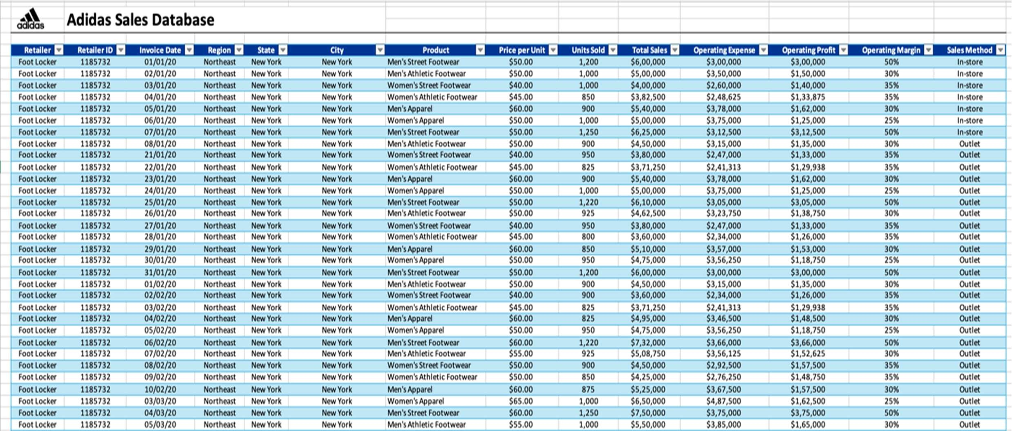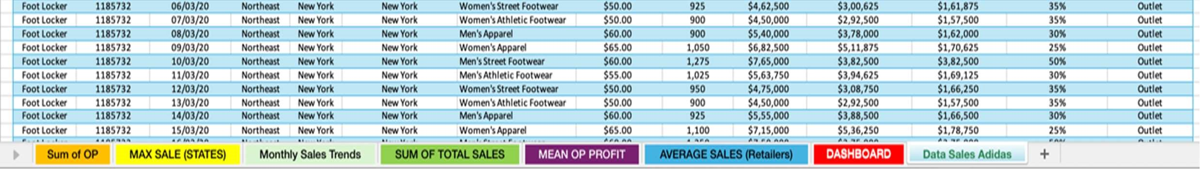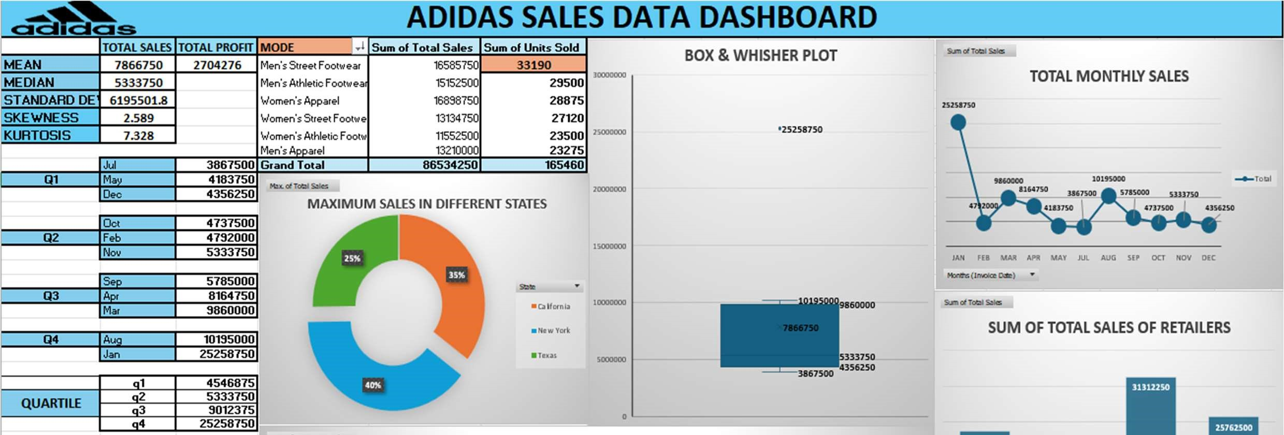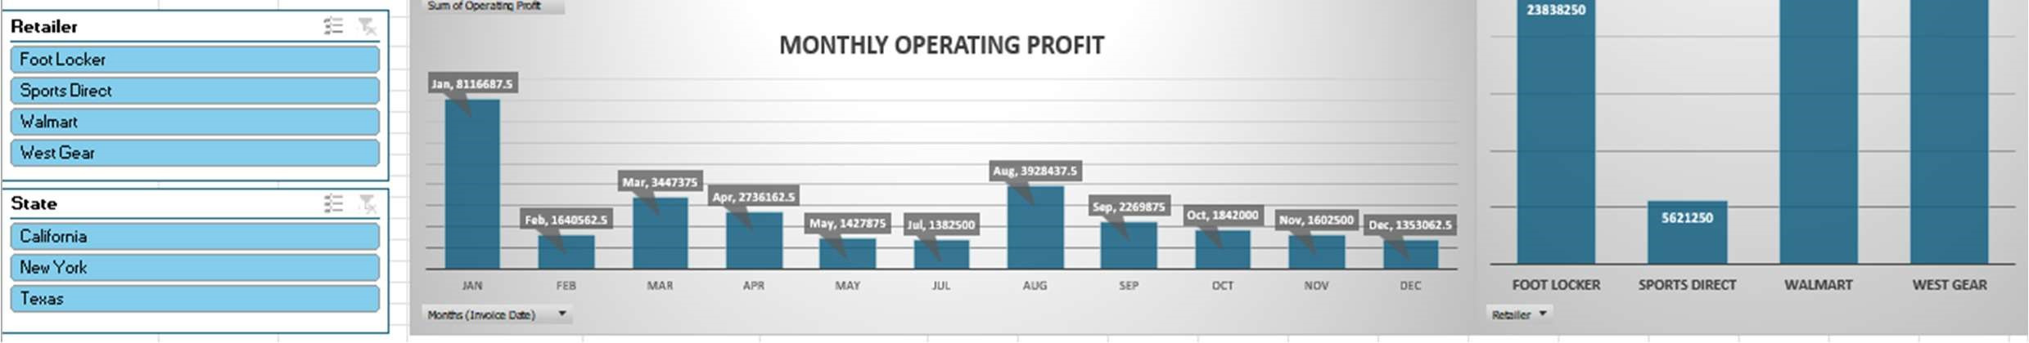

Measures Of Central Tendency And Dispersion

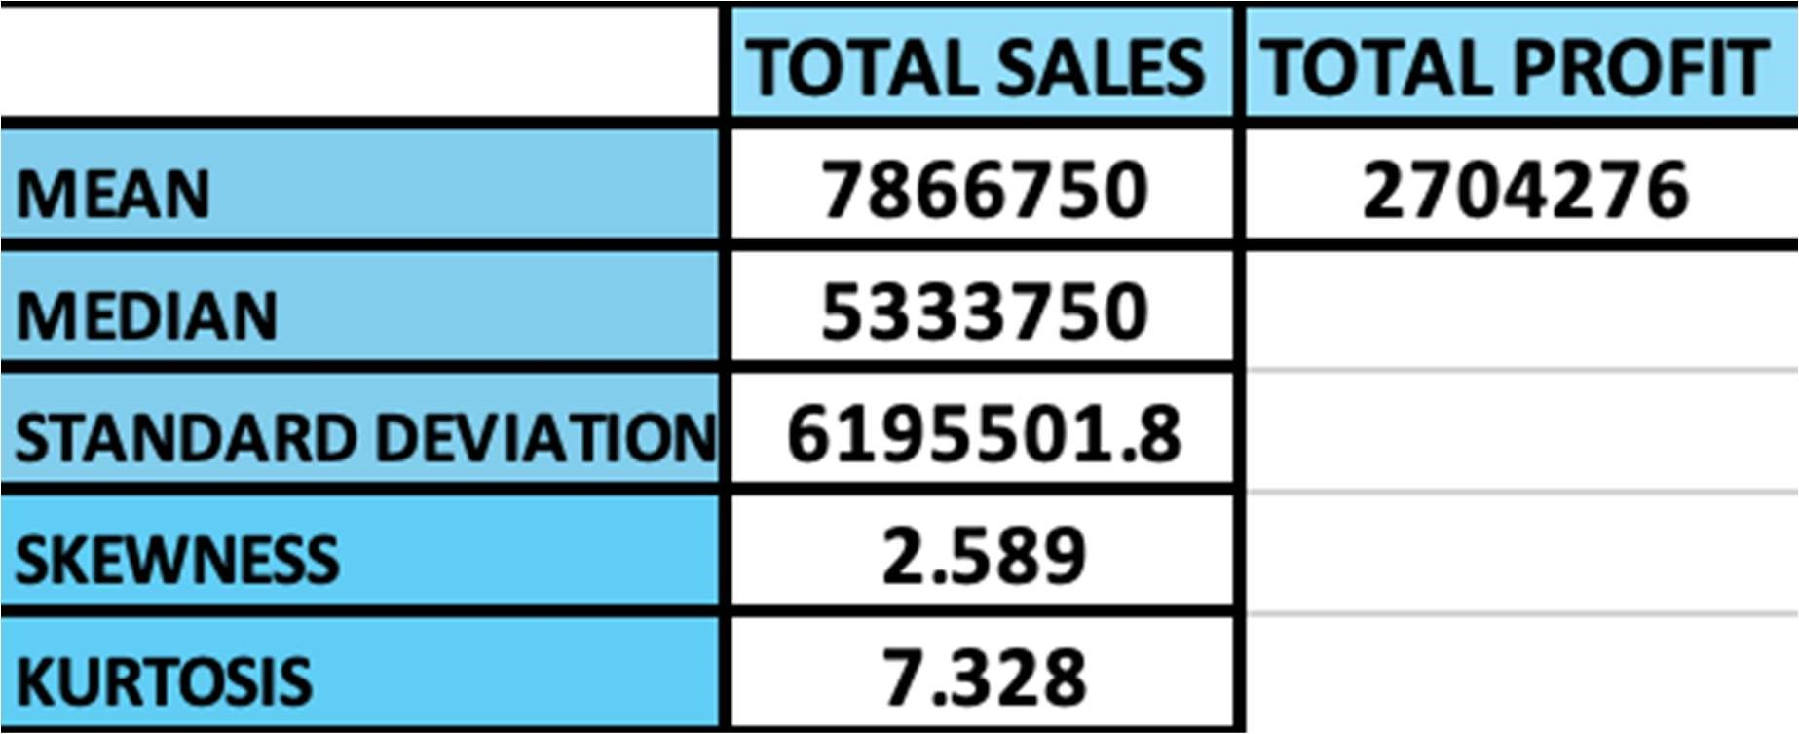

# **Interpretation**

1. Mean



25258750

4792000

9860000

8164750

4183750

3867500

10195000

5785000

4737500

5333750

4356250

JAN

FEB

MAR

APR

MAY

JUL

AUG

SEP

OCT

NOV

DEC

MONTHLY SALES



Total

* 1. Average Sales:

The mean of total sales represents the average sales figure across all monthly transactions. A mean of $7866750 demonstrates that monthly transaction that took place was around this figure at Adidas across all months.

But this analysis is insufficient because it is affected by outliers but gives a fair idea of around what figure a retailer should maintain its sales to maintain uniformity.

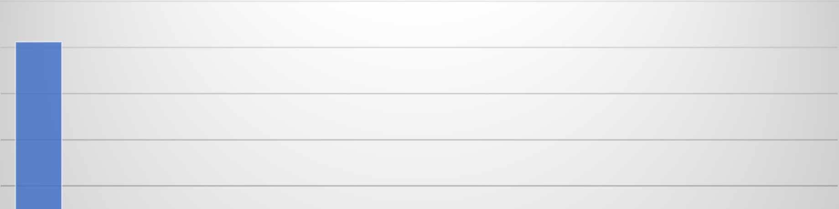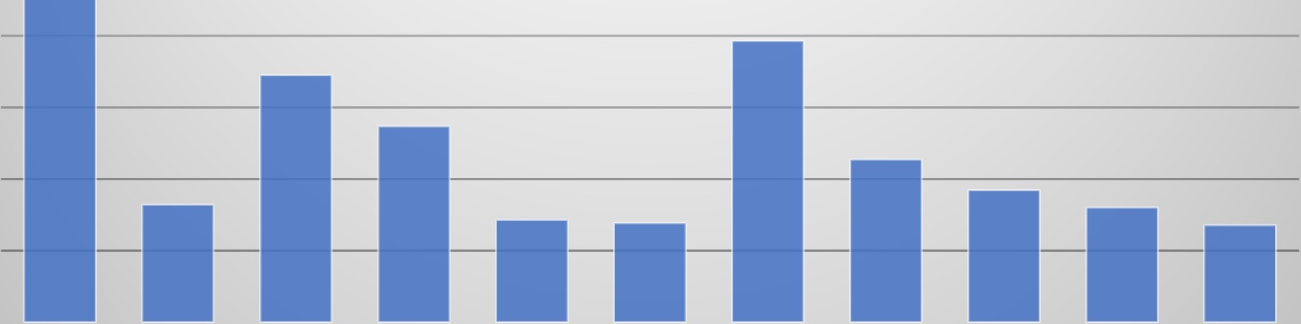

Jan, 8116687.5



Feb, 1640562.5



Mar, 3447375



Apr, 2736162.5



May, 1427875



Jul, 1382500



Aug, 3928437.5



Sep, 2269875



Oct, 1842000



Nov, 1602500



Dec, 1353062.5

JAN

FEB

MAR

APR

MAY

JUL

AUG

SEP

OCT

NOV

DEC

Monthly Operating Profit

* 1. Average Profits:

The monthly average profits stands at $2704276. This demonstrates that the business is earning substantial profits on monthly basis. This indicates that business has a strong financial health and can use these funds in further expanding their horizon and declare more dividend for their investors.

1. Median (Sales)

The median stands at $5333750. This shows the presence of season sales in form of outliers giving a clear picture to the company about its high season months.

With this analysis, the company can divide their calendar year into off season and on season months. The sales value of months below median shows that the company is underperforming in those specific months.

1. Mode (Unit Sold)

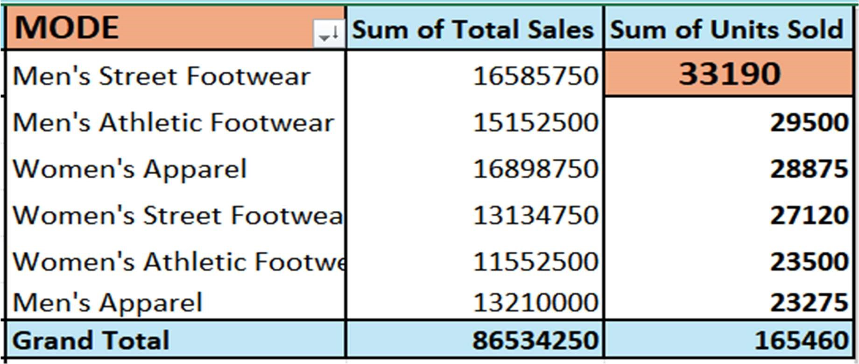

The product selling most articles in Men’s Street footwear standing at 33190 units followed by Men’s Athletic Footwear at 29500 units. This shows that the company should constantly concentrate on promoting their star products category and continue research in enhancing those products to boost sales.

Whereas the least selling product is Men’s Apparel at 23275 followed by Women’s Athletic Footwear. This shows that the company needs to conduct more market research and take customer feedback, revise their strategies to cater the needs of customers interested in these categories.

1. Standard Deviation (Sales)

The standard deviation for monthly sales stands at $6195501.809. This indicates high variability in monthly sales and shows inconsistency questioning company’s sales strategies across different months. The company needs to identify patterns that leads to immense rise and falls in the sales and needs to uniform this trend to maintain stability in their monthly sales performance.

1. Quartiles

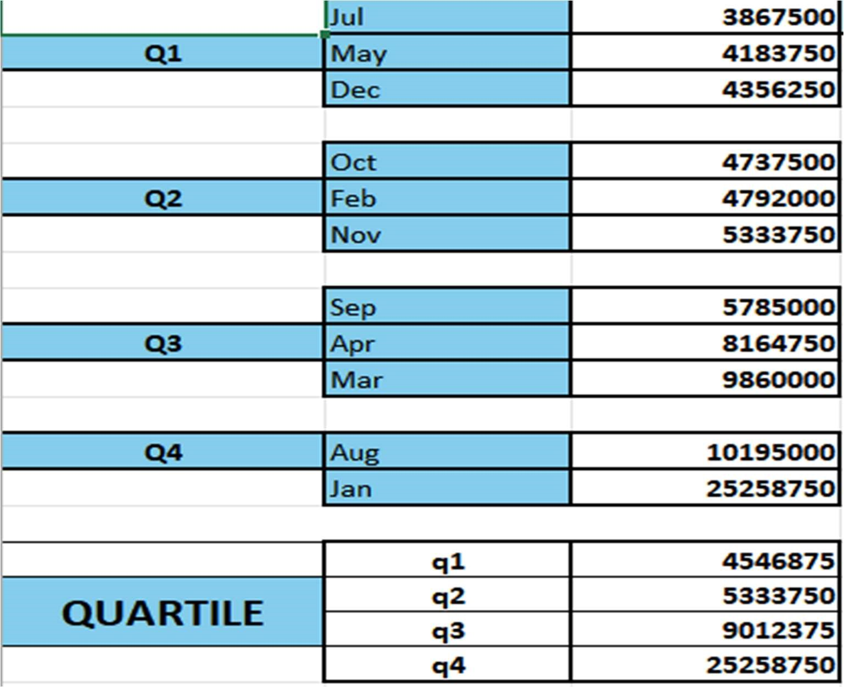

After arranging months based upon the volume of sales, the data is divided into 4 quartiles so that a combined sales strategy can be devised for the months lying in that specific quartile. Q1 shows the least selling months whereas Q4 shows highest selling months. Based upon the groupings, a cumulative strategy can be devised for a specific quartile which will save the management’s efforts and time on conducting research and devising strategies for an individual month.

3867500

10195000

25258750

4356250

5333750

9860000

7866750

0

5000000

10000000

15000000

20000000

25000000

30000000

BOX & WHISHER PLOT

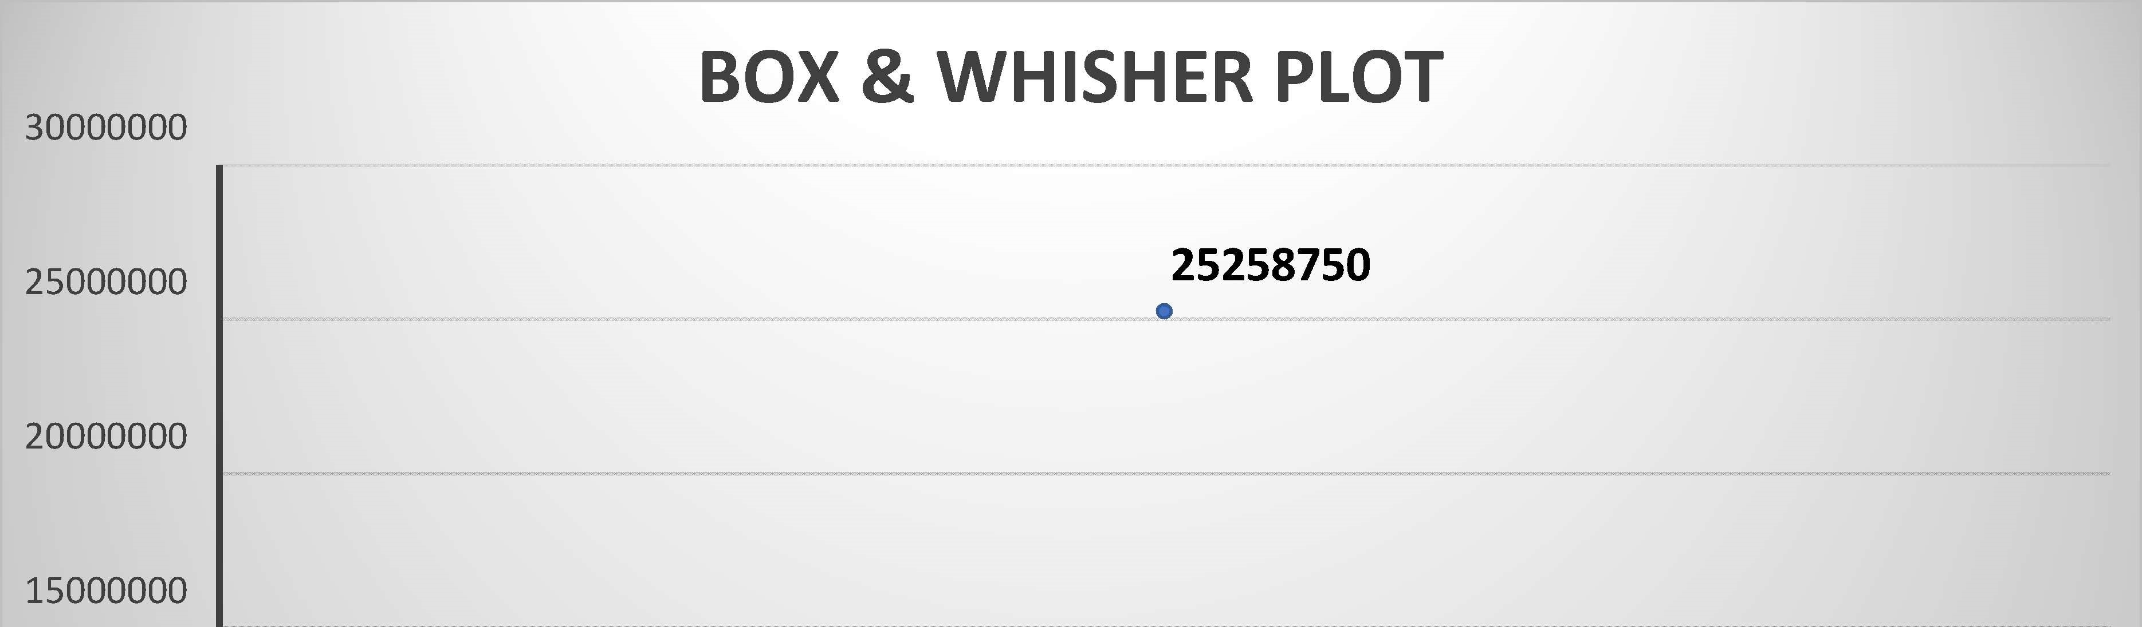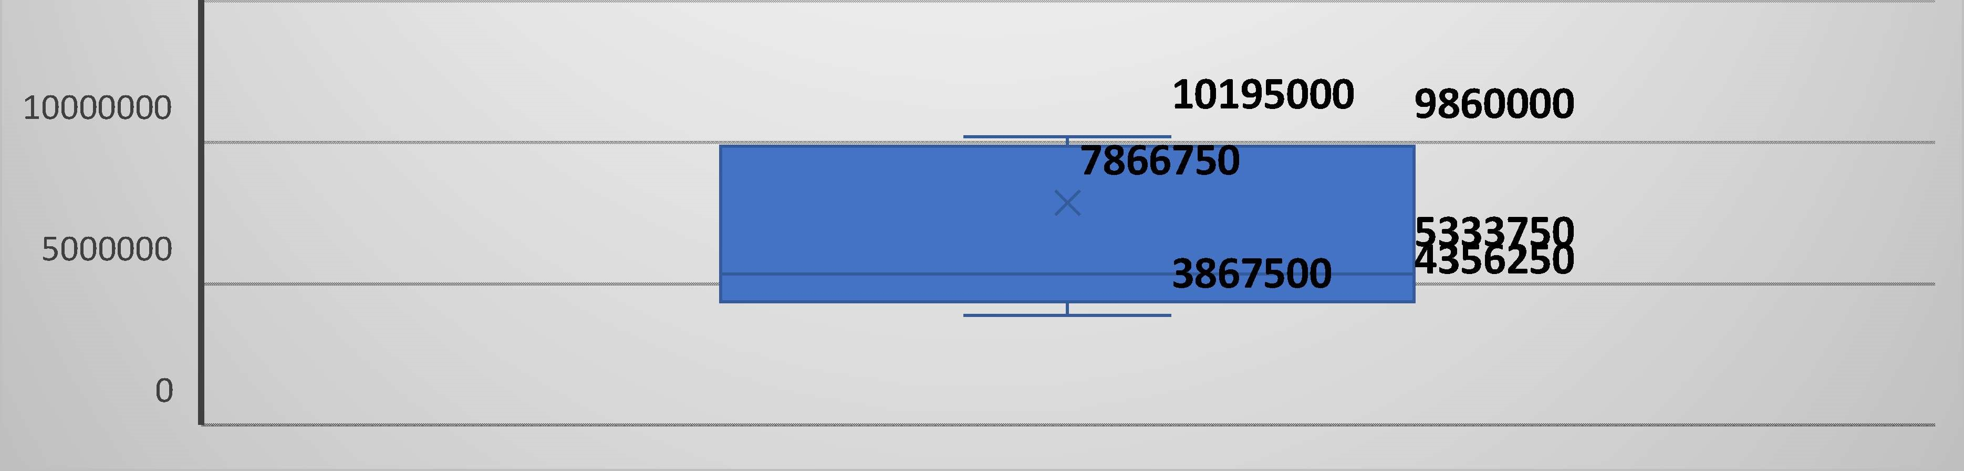

1. Skewness (Sales)

The skewness of data is 2.589 ; which indicates there is a high positive skew.

A positive skew is due to January sales which is extremely high and is pulling the average up. This shows that as manager we need to focus on comprehensive performance of sales of every month rather than just boosting sales of one month.

This could also imply that the company may only be running more promotional offers or discounts during the new years’ time.

1. Kurtosis (Sales)

The kurtosis is extremely high at 7.328; This is much higher than kurtosis of a normal distribution which stands at 3.

This implies that there is very high risk in terms of sales, if sales in the performing month i.e.

Jan dips, the overall and average sales of the company would sink drastically.

As a manager it becomes crucial to analyze the consumer behavior and the factors which are leading to variability in sales.

# **Conclusion**

After drawing inferences from analysis on Adidas sales and profits, we have come to the conclusion that the financial performance of Adidas is strong with a solid average sales and profits. However, we have also identified key areas on which company has to pay attention. There is a high Standard Deviation and Skewness with respect to monthly sales which indicates sales inconsistency. This calls for consistent diversified sales strategies throughout the year.

There are certain products which are performing extremely well whereas others are not so the company needs to focus on expansion and contraction accordingly.

So overall financial health of the company is good, but it also needs to focus on stable and sustainable flow of revenue throughout the year.

# References

Kaggle: https://www.kaggle.com/

Wikipedia: https://en.wikipedia.org/wiki/Adidas

Moodlel: https://moodlel.jaipuria.ac.in/lms/course/view.php?id=3143